CS402 - THEORY OF AUTOMATA

**FINALTERM EXAMINATION**

SPRING 2007

|  |  |  |
| --- | --- | --- |
| Question No: 1 | ( Marks: 1 ) | - Please choose one |
| PDA is only used to represent a regular language. | | |
| ► True |  |  |
| ► False |  |  |
|  |  |  |
| Question No: 2 | ( Marks: 1 ) | - Please choose one |
| If L is a regular language then LC is also a regular language. | | |
| ► True |  |  |
| ► False |  |  |
|  |  |  |
| Question No: 3 | ( Marks: 1 ) | - Please choose one |
| A production of the form non-terminal  string of two non-terminal is called a live | | |
| Production. |  |  |
| ► True |  |  |
| ► False |  |  |
|  |  |  |
| Question No: 4 | ( Marks: 1 ) | - Please choose one |
| we can find a CFG corresponding to a DFA. | | |
| ► True |  |  |
| ► False |  |  |
|  |  |  |
| Question No: 5 | ( Marks: 1 ) | - Please choose one |
| START, READ, HERE and ACCEPTS are conversions of the machine | | |
| ► True |  |  |
| ► False |  |  |
|  |  |  |
| Question No: 6 | ( Marks: 1 ) | - Please choose one |
| A CFG is said to be ambiguous if there exists at least one word of its language that can | | |
| be generated by different production trees | | |
| ► True |  |  |
| ► False |  |  |
|  |  |  |
| Question No: 7 | ( Marks: 1 ) | - Please choose one |
|  |  |  |

Syntax tree or Generation tree or Derivation tree are same tree ► True

► False

|  |  |  |  |
| --- | --- | --- | --- |
| Question No: 8 | ( Marks: 1 ) | - | Please choose one |
| The symbols that cannot be replaced by anything are called terminals | | | |
| ► True |  |  |  |
| ► False |  |  |  |
|  |  |  |  |
| Question No: 9 | ( Marks: 1 ) | - | Please choose one |

The production of the form non-terminal  one non-terminal is called unit production

► True

► False

|  |  |  |  |
| --- | --- | --- | --- |
| Question No: 10 | ( Marks: 1 ) | - | Please choose one |
| DFA and PDA are equal in power. | | |  |
| ► True |  |  |  |
| ► False |  |  |  |
|  |  |  |  |
| Question No: 11 | ( Marks: 10 ) |  |  |

a) Define Describe the following terms: [Note: maximum in 20 to 30 words for each]

I. CNF

* 1. Regular Grammar

1. Convert the following CFG into CNF S → CDCD

C → 0|Λ D → 1|Λ

|  |  |  |
| --- | --- | --- |
| Question No: 12 | ( Marks: 10 ) |  |
| **a)** Construct RE’s for following languages overΣ= {0, 1} | | (6) |

* 1. All words in which “1” never follows “0”. ( “0” never appears before “1”)
  2. All words which begin and end with different letters.

1. How many minimum states can be there in an NFA of language having all word with “101” at the end? (4)

|  |  |  |  |  |  |
| --- | --- | --- | --- | --- | --- |
| **HINT**: Build NFA for language for yourself but write only number of minimum states. No | | | | |  |
| need to build NFA in software. | | |  |  |  |
|  |  | |  |  |  |
| Question No: 13 | ( Marks: 10 ) | |  |  |  |
| **a)** Is this an FA or NFA? | | | (2) |  |  |
| **b)** Determine the CFG corresponding to the above FA or NFA | | | | (8) |  |
|  |  | |  |  |  |
| Question No: 14 | ( Marks: 10 ) | |  |  |  |
| **a)** Given CFG (Context Free Grammar): | | |  | (6) |  |
| S → bS | aX | Λ | | |  |  |  |
| X → aX | bY | Λ | | |  |  |  |
| Y → aX | Λ | | |  |  |  |
| Derive following strings from above CFG. Show all steps. If string cannot be derived then | | | | |  |
| describe it. | **i.** | baabab |  |  |  |
|  |  |  |  |
|  | **ii.** | ababaab |  |  |  |
| **b)** Describe language of following PDA (Push Down Automata): | | | | (4) |  |
| [ Note: Don’t write more than two to three lines for each. Only write to the point. ] | | | | |  |
|  |  |  |  |  |  |

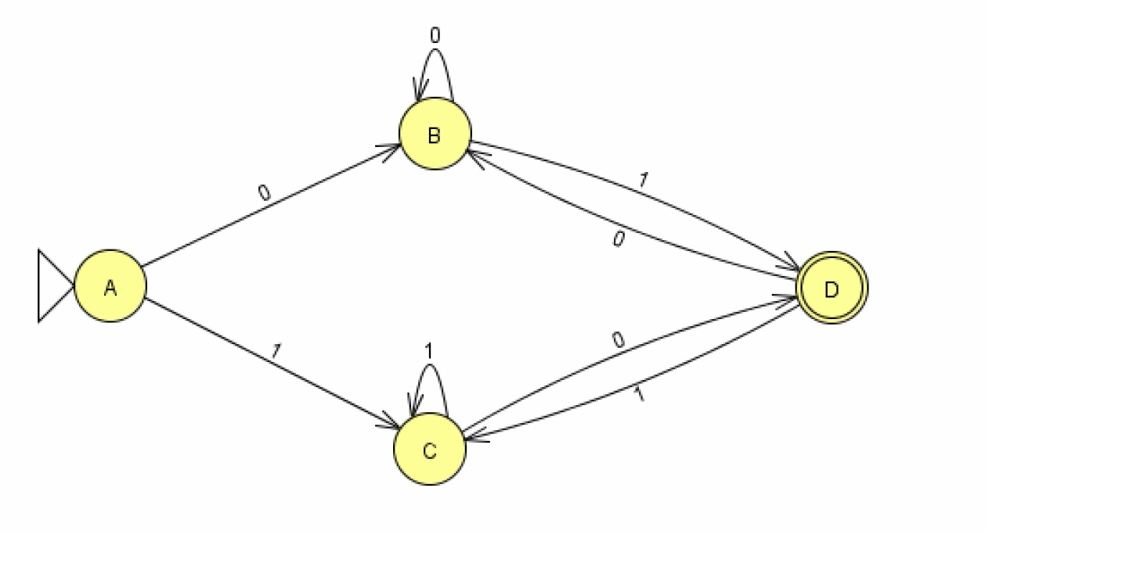

|  |  |  |  |  |
| --- | --- | --- | --- | --- |
| START |  |  | 1 |  |
|  |  | 1 |  |  |
| 0 |  |  |  |  |
|  |  | READ | 0 |  |
| READ | 1 | READ |  |
|  |  |
|  |  |  |  |

ACCEPT

0

REJECT

|  |  |  |
| --- | --- | --- |
| Question No: 15 | ( Marks: 5 ) |  |
| Given a CFG below, | | [5] |

S → bS | aM

M→ bM | aF

F → bF | aM | ^

What is language accepted by above CFG?